Monetary and Fiscal Policy

The two most powerful remedies-to-tools in the management and stabilization of economies are monetary and fiscal policies. These policies are broadly aimed at influencing aggregate demand, economic growth, repetitive employment, rates of inflation, and other macroeconomic indicators. While their goals may be similar, they work through different mechanisms with varying roles in the making of economic policy.
Monetary policy refers to central bank activities oriented to influence the quantity of money and credit in an economy. Fiscal policy refers to the government decisions on taxation and expenditure. All these tools of monetary and fiscal policy have to be used for modulating economic activity over time.
Fiscal policy, influences the level of government expenditure, level of taxation, and amount of borrowing directly, while monetary policy basically manages money supply and interest rate conditions and subsequently credit conditions with the goal of price stability and achievement of growth.

Importance of Monetary and Fiscal Policy
Monetary and fiscal policies are the key instruments that governments or central banks use in trying to manage an economy towards the attainment of various diversified macroeconomic goals such as:
- Stabilization of Economic Growth
- Controls of Inflation
- Unemployment Management
- Stability in Finance

Monetary Policy
Monetary policy is any action by a central bank that manages an economy's money supply, interest rates, and its resultant credit conditions. The basic goals are usually price stability—defined as low and stable inflation—and promotion of sustainable economic growth.

Types of Monetary Policy : Monetary policy involves actions by the central bank to affect money supply and interest rates and ultimately drive macroeconomic objectives of price stability, full employment, and economic growth. Central banks conduct monetary policy using various tools and for differing objectives with different impacts on the economy. Types of monetary policy demonstrate how central banks shape the economy's condition and react to problems.

Interest Rate Policy : The center of monetary policy usually is the changing interest rates that might ultimately alter the course of economic activity. Central banks turn to interest rates as a lever in an:
- Expansionary Monetary Policy: The central banks lower interest rates when it is slackening, stimulating borrowing and spending. Lower interest rates charge low prices for loans to businesses and people, thus motivating them to invest, consume, and enlarge the economy as a whole.
- Contractionary Monetary Policy: On the other side, while the rate of inflation tends to go too high or when the economy has started overheating, interest rates may be hiked by central banks. Higher rates raise the cost of credit for the whole economy, reducing consumer spending and business investment that might help cool an overheated economy.

Open Market Operations : Open market operations entail buying and selling government securities on the open market to regulate the money supply:
- Expansionary OMO: Central banks buy government securities from commercial banks and the public. This leads to an increase in liquidity followed by increasing liquidity in the financial system, hence bank reserves, which in turn brings about a decrease in short-term interest rates. Lower borrowing costs prompt lending and economic activity.
- Contractionary OMO: It reduces money supply and raises short-term interest rates due to contractionary OMO, and the higher rate will deter borrowing, hence spending is contained, therefore avoiding inflation or asset bubbles. Selling by central banks of government securities to commercial banks and the public.

Reserve Requirements : Reserve requirements refer to the percentage of deposits that each bank must hold as reserves.
- Lowering Reserve Requirements: It allows commercial banks to lend more of their money, whereas raising it presents an opportunity to lend less and thus reduce the money in circulation, reducing inflation and therefore slowing down spiraling economies. By lowering the reserve requirements, more of the money that banks have will be lent out, thereby increasing money supply, reducing interest rates, and boosting economic growth by making credit more available.
- Raising Reserve Requirements: If reserve requirements are raised, less money will be lent out and thus reduce borrowing, causing an increase in the cost of borrowing, and hence cooling off an overheating economy.

Roles of Monetary Policy : These are actions on the part of a central bank, aimed at managing money supply and interest rates.
- Controlling Inflation
- Stabilization of the Economy
- Financial Stability
- External Exchange Rate Management
- Supporting Long-Term Economic Growth

Fiscal Policy

Fiscal policy is the process of influencing the economy through government expenditure and taxation. It involves government decisions concerning the amount of money the government needs to spend on public goods and services and how much revenue it needs to generate from both private individuals and business enterprises through taxation. The most important objectives of fiscal policy are to foster economic growth and development, rein in rising inflationary pressures, reduce unemployment of resources, and ensure sustainable fiscal-balance positions.

Types of Fiscal Policy : Fiscal policy refers to the government's decisions about taxation and spending levels that influence aggregate demand, employment rate, and the pace of economic growth. This becomes a very vital tool in the hands of governments to stabilize the economy in case of fluctuations, stimulate its growth, and ensure efficient allocation of resources. The type of fiscal policy would include both discretionary measures—the changing of tax rates and government expenditure being examples—and automatic stabilizers, which adjust automatically with the cycles of the economy. Effective use of fiscal policy needs to balance short-term objectives of aggregate demand management with long-term fiscal sustainability and stability.

Government Spending : Fiscal policy encompasses government spending on goods and services. This, in effect, becomes the definition of fiscal policy:
- Expansionary Fiscal Policy: In times of recession, governments raise expenditure levels to infrastructure, education, health, and other sectors. The injection of money into the economy kick-starts economic activity, generates employment, and shores up aggregate demand, thus helping the economy climb out of recession.
- Contractionary Fiscal Policy: When the economy is in an expansionary state or when inflationary pressures are brewing, the government may cut back on spending. This reduces budget deficits, prevents overheating, and thus stabilizes prices and helps to impose fiscal discipline.

Taxation : Fiscal policy also includes changes in tax rates and policies:
- Fiscal Policy through Tax Cuts: The government might reduce taxes so that people could have more disposable income and promote consumer and investment spending. This stimulates economic activity, thereby supporting economic growth, in boosting aggregate demand.
- Contracting Fiscal Policy through Tax Increases: By increasing taxes, governments can reduce disposable income and spend it further to prevent excessive consumer-spending, especially during periods of inflation or overheating of the economy. A high taxation rate can definitely lower an overheated economy and sustain fiscal stability.

Transfer Payments : Transfer payments refer to government payments to individuals or a group of persons, and in return, no good or service is directly acquired:
- Expansionary Transfer Payment: Amidst the slowdown of an economy, transfer payments are augmented, including unemployment benefits, welfare payments, or higher social security benefits. Incomes of households rise along with consumer spending, which plays a vast role in the stabilization of demand within the economy.
- Contractionary Transfer Payment: If the economy is out on an expansion spree or when fiscal deficits have to be reined in, then the government does resort to the option of lowering transfer payments. This in effect brings down the quantum of government expenditure, thereby reducing fiscal deficits and long-term fiscal sustainability.

Roles of Fiscal Policy : Fiscal policy refers to governmental expenditure and revenue policies that influence the level of economic activity. The distinct roles played by fiscal policy include:
- Stimulating Aggregate Demand
- Managing Fluctuations in the Economy
- Income and Wealth Redistribution
- Long-Term Investment Encouraged
- Fiscal Sustainability Guaranteed

Difference Between Fiscal and Monetary Policy
The two most centrally indirect means through which governments and central banks try to guide economic activity and hence stabilize it are fiscal and monetary policies. While the objectives of the policies, like growth promotion and keeping inflation in a tight rein, are the same, the mechanism by which they work differs, and different actors come into play.

Aspect | Fiscal Policy | Monetary Policy
Definition | Refers to government decisions on spending, taxation, and borrowing to influence economic activity. | Involves central bank actions to manage money supply, interest rates, and credit conditions.
Authority | Determined and implemented by government bodies (legislature and executive). | Implemented by the central bank (independence varies by country).
Objectives | Economic growth, Price stability, Employment levels, Income distribution | Price stability, Economic growth, Employment, Financial stability
Instruments | Government spending, Taxation policies, Borrowing and debt management | Open market operations, Discount rates, Reserve requirements
Impact on Economy | Direct impact on aggregate demand and consumption. Long-term investment in infrastructure and social programs. | Indirect impact through interest rates and credit availability. Short-term adjustments to economic fluctuations.
Adjustment Speed | Often involves longer implementation periods due to legislative processes and budget cycles. | Can be implemented relatively quickly, with interest rate changes having immediate effects on the economy.
Flexibility | Less flexible in responding to short-term economic changes compared to monetary policy. | More flexible in adjusting to economic changes due to quicker implementation and reversibility.
Get 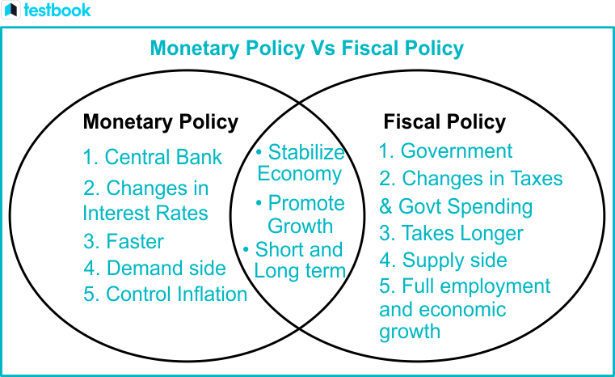

The monetary and fiscal policies are two major wheels of the economy that encompass activities for economic development. In monetary policy, the supply of money supersedes the rate of interest with a view to influencing economic activity. Fiscal policy consists of government expenditure, taxation, and borrowing. Such policies, fully directed towards having stable economic growth with very low instances of unemployment and low controlled inflation, try to have a well-balanced and resilient economy amidst diverse economic challenges. Each of these has mechanisms and implications that policymakers, economists, and businesses must understand in order to negotiate the complexities of modern economies effectively.

